**SMART DOORBELL SYSTEM**

**Introduction**

The first COVID-19 case was first reported in January and after months it is in Lakhs all over the country. The outbreak has been declared an epidemic. According to the World Health Organization maintaining social distancing and keep yourself hygiene are the only ways to prevent contamination.

But in this extreme situation, we can't avoid visiting anyone's place. In this scenario, we will use the doorbell but in this case, there is a high risk of contaminating the virus.

This problem can be solved by making a touch-less doorbell where you can put your hand in front of the sensor and a buzzer sound will be generated from inside.

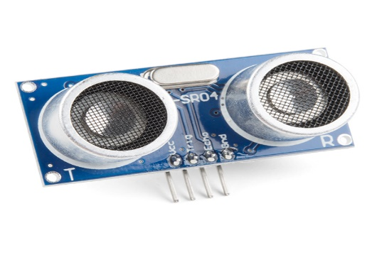**COMPONENTS**

* [HC-SR04](https://amzn.to/3eiIXnp)
* [Arduino UNO](https://amzn.to/36X2rLU)
* [Buzzer](https://amzn.to/2yxYTms)
* [Bread Board](https://amzn.to/2B3XYv3)
* [Wires](https://amzn.to/2zwLMCA)

**Application**

* **Proximity Detection**
* **Ranging Measurement**
* Tank Level
* Liquid level sensor
* Robotic sensing
* Stacking height control
* Vehicle detection for car wash and automotive assembly
* Irregular parts detection for hoppers and feeder bowls

**Objective**

During this activity ,you will help students to achieve following objectives

1. Understanding the principle and operation of ultrasonic distance sensor

2. Design algorithm and flowchart to detect obstacle and get alerted

3. Programming ultrasonic distance sensor using Arduino uno

4. Interfacing ultrasonic distance sensor withArduino uno

**Algorithm**

1. initialise trigger signal

2. initialise echo signal

3. initialise buzzer as output

4. send trigger signal continusly

5.read the staus of echo signal pin

6.check for echo signal if echo signal not receive then continue

7. if echo signal receives means there is obstacle ,buzzer immediately rings up

8. end

**Flowchart**

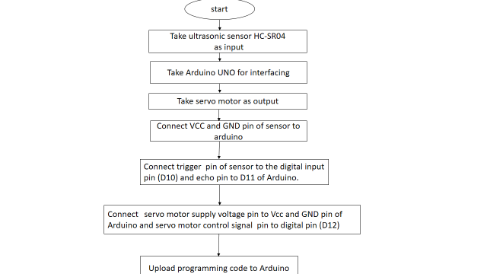

**Programming**

int trigPin = 10;      
int echoPin = 9;      
int bell=6;  
   
void setup() {  
  digitalWrite(bell, LOW);  
  pinMode(trigPin, OUTPUT);  
  pinMode(bell,OUTPUT);  
  pinMode(echoPin, INPUT);  
  delay(100);  
}  
   
void loop() {  
   
  digitalWrite(trigPin, LOW);  
  delayMicroseconds(5);  
  digitalWrite(trigPin, HIGH);  
  delayMicroseconds(10);  
  digitalWrite(trigPin, LOW);  
  
  int duration = pulseIn(echoPin, HIGH);  
  delay(50);  
    
  if (duration <= 600){  
     digitalWrite(bell, HIGH);  
  
  }  
  
  else{  
      digitalWrite(bell, LOW);  
  
      
  }  
}

**Hardware**

**Instruction**

1.connect vcc and ground pin of ultrasonic sensor to the5 v supply voltage and ground pin of arduino board

2. connect trigger sinal pin of sensor to the digital input pin D10.

3. connect echo signal pin of sensor to digital input pin D9.

4.connect positive polarity of buzzer to digital input pin D6 and negative pority to the ground.



